 | Erasmus+ Programme  TEACHING/training mobility agreement (STA/STT)
  
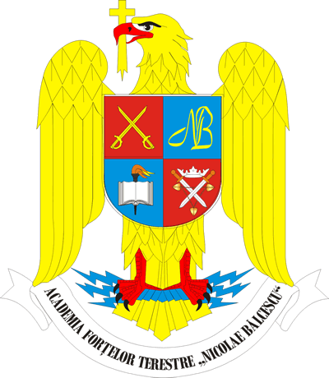

ROMANIA
LAND FORCES ACADEMY „NICOLAE BALCESCU” SIBIU
Revoluţiei Street no. 3-5, 550170, Sibiu, RO
Phone: +40-269-432990 Fax: +40-269-215554

Confirmation of Erasmus+

TEACHING/training mobility (STA/STT)

TEACHER
Family name:
First name:

SENDING INSTITUTION
Country:
Name of sending institution:
Faculty/Department:
Erasmus+ code:

RECEIVING INSTITUTION
Country:
Name of receiving institution:
Faculty/Department:
Erasmus+ code:
This is to certify that the .......................... accomplished the training mobility agreement under the Erasmus+ programme for our institution from ................ to ................ of the ................ academic year.
Main content of the training mobility agreement (name of the lecture/seminar, other activities):

Date: ................ Signed:
..................................
(Erasmus+institutional coordinator)

