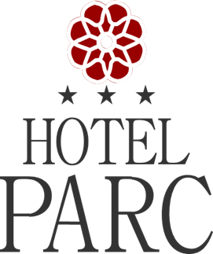

Reservation Form
iMAF 2022 - 13 JUNE – 16 JUNE 2022

NAME :

Period :

Room type & rates :
☐SINGLE room - Price: 55 EURO / NIGHT + CITY TAX 1%
☐ DOUBLE room- Price: 65 EURO / NIGHT + CITY TAX 1%

- Breakfast , VAT included
- Reservations will be made until : 1.06.2022 by email :sales@parchotelsibiu.ro
- Hotel contact person : Galata Dan - +40786498886

