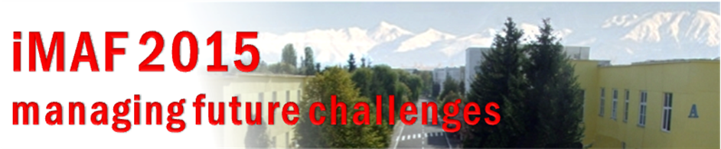
Creating an International Semester – the next step in a Common Education for the European Officer

Author’s name:
(family name, first name)
Author’s title:
(military rank, academic degree(s))
Institution:
Country:

Please state your institution’s point of view regarding the following question:

Which competences/qualifications should be acquired by the students participating in an international semester abroad, taking into account the competences/qualifications they should have?

A technical information: please specify the beginning/end of winter/summer semesters in your institution.

Additional information:
- when describing the competences/qualifications, take into consideration the “tree of competences“ found in the attachments;
- your contribution will be published in iMAF 2015 book;
- the articles should have up to 4 pages;
- the articles should be written in word document;
- the articles should be sent on the e-mail address imaf@armyacademy.ro;
- the deadline for articles is May 26, 2015.

