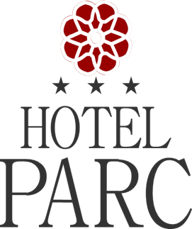
http://www.parchotelsibiu.ro/en/

Reservation Form
EUMACS 12.06.2019-15.06.2019

NAME:_____________________________________________

Period:______________________________________________

Room type: ________________________________________
Rates: -SINGLE - Price: 50 EURO / NIGHT + CITY TAX 1%
=DOUBLE - Price: 60 EURO / NIGHT + CITY TAX 1%

- Breakfast, VAT included
- Reservations will be made until: 15 April 2019 by email: office@hotelparcsibiu.ro or fax +40269423559 .

